**Name:** M.Floric Esther

**College** **code:** 9530

**College name:** St.Mother Theresa Engineering College

**Team id:**

**Naan Mudhalvan id**:au953021104014

**Project Name:** Image Recognition with IBM cloud

**Problem Solution:**

IBM Cloud Image Recognition

Problem solution for image recognition with IBM cloud

To create a solution for image recognition using IBM Cloud, you can follow these general steps:

**Set up an IBM Cloud Account:**

If you don’t already have one, sign up for an IBM Cloud account at <https://cloud.ibm.com/>. You may need to provide billing information, but IBM often offers free tiers for certain services.

**Choose a Service:**

IBM offers several services for image recognition. One popular choice is IBM Watson Visual Recognition, which uses deep learning to analyze and classify images.

**Create a Visual Recognition Service:**

In the IBM Cloud dashboard, create an instance of the Visual Recognition service. Configure it according to your needs, and make note of the API key or credentials provided.

**Collect and Prepare Data:**

Gather a dataset of images that you want to recognize. Ensure your data is properly labeled and organized. IBM Watson Visual Recognition supports custom model training, which can be useful if you have specific recognition needs.

**Train the Model (if necessary):**

If you have a custom dataset, you can train your model using IBM Watson Visual Recognition’s tools. Follow the documentation and guidelines to train your model effectively.

**Integration with Your Application:**

Use the API key or credentials from your Visual Recognition service to integrate it into your application. You can use the API to send images for recognition and receive results.

**Post-processing and Display:**

Once you receive recognition results, you can process the data as needed for your application. This might involve displaying labels, confidence scores, or taking specific actions based on the recognition results.

**Testing and Optimization:**

Test your image recognition solution thoroughly, and consider optimizing it for performance and accuracy. You can fine-tune your model if necessary.

**Deployment:**

Deploy your application with the integrated IBM Cloud image recognition service to a web server, cloud platform, or any suitable hosting environment.

**Monitoring and Maintenance:**

Continuously monitor the performance of your image recognition solution and make necessary updates and improvements. IBM Cloud provides tools for monitoring and managing your services.

Remember to refer to IBM’s official documentation and support resources for specific details on each step, as their services and offerings may evolve over time.

**Methodology:**

*~~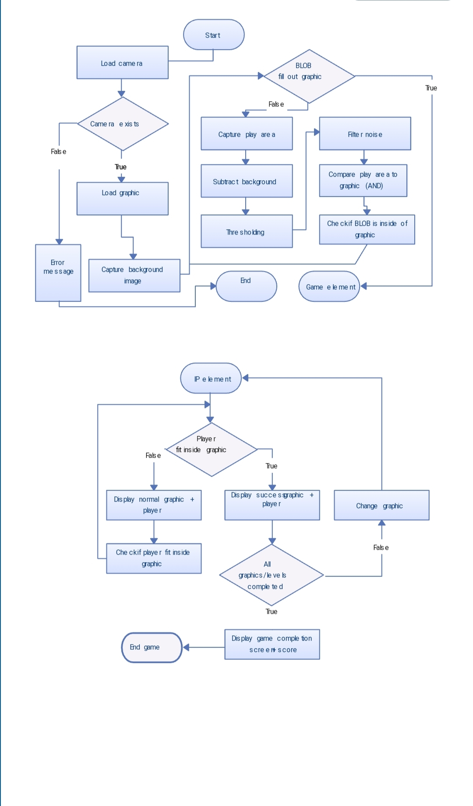~~*

**Git Hub link :**